**OGEL SHOE COMPANY (PRIVATE) LIMITED**

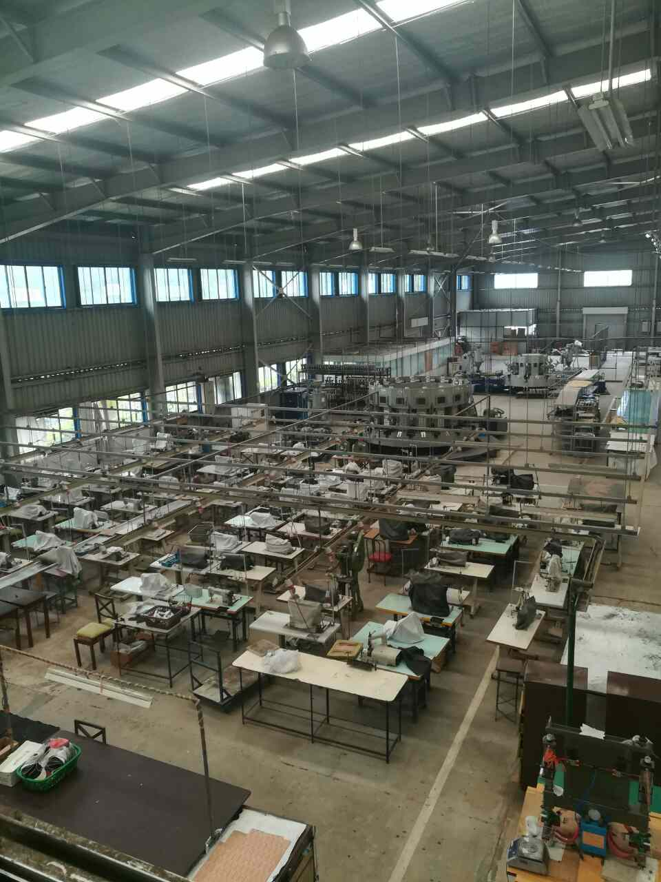

## BACKGROUND

OGEL shoe company (Private) Limited was formed and incorporated in 12th of July 2007 in Ulapane, Kandy District. The company’s primary objective is to meet the challenging demands of market trends associated with both industrial and street fashion footwear, by combining traditional craftsmanship with quality and modern production equipment and technology.

Ogel Shoe Company is a medium scale organization with 100 employees; with key activities of designing, manufacturing, supplying, distributing & selling, wide range of quality footwear to school children, gents & different defense sectors (Army, Navy, and Police) also other industries.

The main strengths of Ogel shoe company are innovative workforce with necessary skills and experience, the floor area of 40,000sq business premises with factory, warehouse, shop & the office, machinery with new technology and the modern security systems, who cater to the today’s challenging need of quality footwear with exceeding customers satisfaction.

**Main activities:** Manufacturing, retailing, wholesaling and Supplying of various type of footwear for males, school children, work related safety shoes etc.

|  |  |  |  |  |  |  |  |  |  |  |  |  |  |  |  |  |  |  |  |  |  |  |  |  |  |  |  |  |  |  |  |  |  |  |  |  |  |
| --- | --- | --- | --- | --- | --- | --- | --- | --- | --- | --- | --- | --- | --- | --- | --- | --- | --- | --- | --- | --- | --- | --- | --- | --- | --- | --- | --- | --- | --- | --- | --- | --- | --- | --- | --- | --- | --- |
| |  |  | | --- | --- | | BRAND | **OGEL** | | PROJECT | SHOE MANUFACTURING PLANT | | LOCATION | CENTRAL PROVINCE – ULAPANE, SRI LANKA | |  | LAND AREA – 4 ACRES | | AREA | 45000 SQ FT | | PROJECT VALUE | USD 10m | | NO OF EMPLOYEES | 100 | | SUBCONTRACT STAFF | 50 | | DESIGN TYPES | 10 | | APPROVALS | ALL APPROVALS OBTAINED | | PRESENT PROJECT STATUS | FACTORY CONSTRUCTION COMPLETED,  SHOE PRODUCTION EQUIPMENT INSTALLED  PRE-TRAILS DONE  ABOUT TO START PRODUCTION WITH FIRM EXPORT ORDER |  |  |  | | --- | --- | | INVESTMENT REQUIREMENT | USD 7.5M |  |  |  | | --- | --- | | CONTACT PERSON | Mr. A.W. Warnakula – Chairman  Email – awwarnakula@gmail.com | |  | TP – 00 94 777 365335 | | SECURITY OF INVESTMENT | A BANK GUARANTEE IN LKR, WOULD BE ISSUED FOR THE TOTAL PROJECT COST TO THE INVESTOR | | BANK GUARANTEE PROVIDER | ANT MANAGEMENT SERVICES (PVT) LTD  (Under this bank guarantee scheme the total finances & financial management would be handled by a team of experts, under this Company to ensure the project success. Bank guarantee would be issued at the time of making the investment, through an inward investment account.) | | RISK TO THE INVESTOR IN CASE OF PROJECT FAILURE | NIL | | | | |
|  |  |  |  |

OTHER TECHNICAL DETAILS

1. **Main building – Office, stores and factory**

**Ground floor**

Roof - Zinc-Aluminum sheets over iron frame on wide “H” iron trusses, beams and Posts. Heat resistant aluminum foil ceiling underneath.

Walls - Zinc-Aluminum sheet clad with wide “H” iron posts and “C” iron frame with free span.

Floor - 5-6” thick concrete and finished with neat cement.

Accommodation - Factory & packing area, stores, product development room and washrooms

Floor area - 40,000 sq.

Conveniences - Electricity, water service, glazed windows, roller doors, fire – guard system.

**Mezzanine floor**

Roof - Zinc-Aluminum sheets over iron frame on wide “H” iron trusses, beams and Posts. Heat resistant aluminum foil ceiling and soft board ceiling underneath.

Walls - Zinc-Aluminum sheet clad with wide “H” iron posts and “C” iron frame Internal glazed partitioned cubicles with aluminum frame.

Floor - Boarded floor over 12” wide “H” iron beams and swan timber frame. Chairman’s room and conference room – Good quality ceramic

Tiled floor.

Accommodation - Chairman room, meeting room, director room, accountant room, IT room, factory manager room and toilet.

Floor area - 5400 sq.

Conveniences - 3 phase electricity, water service, telephone, A/C, CCTV, washrooms

Glazed doors & windows, interior glazed partitioned cubicles.

1. **Canteen building**

Roof - Zinc-Aluminum sheets on “C” iron frame

Heat resistant aluminum foil ceiling underneath

Gutters and down pipes.

Walls - Zinc-Aluminum sheets clad walls with “H” iron posts.

Floor - Concreted and finished with neat cement

Accommodation - Canteen and 2 changing rooms

Floor area - 2400 sq.

Conveniences - Electricity, water service, Glazed windows

1. **Boiler room**

Roof - Zinc-Aluminum sheets on iron frame on “H” iron posts.

Walls - Zinc-Aluminum sheets clad

Floor - Concreted

Floor area - 400 sq.

1. **Cloak room and toilets**

Roof - Zinc-Aluminum sheets on swan timber frame

Walls - Brick masonry walls, plastered and color washed

Internal faces ceramic tiled

Floor - Concreted and ceramic tiled

Accommodation - Ladies toilets & bath rooms and gents toilets & bath rooms

Floor area - 600 sq.

Conveniences - Electricity, water service, 11 squatting pans, and 08 wash basins and urinals 08 rooms.

1. **Generator room**

Roof - R.C.C. flat roof

Walls - Brick masonry walls with R.C.C. columns, plastered

Floor - Concreted

Accommodation - Generator room and Switch Board room

Floor area - 450 sq.

Conveniences - Electricity 02 no’s, roller doors

1. Security Guard room
2. Rain water harvesting system
3. Under ground water stock tank capacity 75000 liters backed up for emergency purposes
4. 1000 K.V.A.Transformer with capacity bank
5. Fire-Guard system
6. CCTV system
7. Macadamized Drive-way, Compound and appurtenant area
8. Six Hundred air meters covered by lighting protector

**PRODUCTION:**

**Slippers**

Rubber Slippers production capacity 10,000 pairs per shift (8 hours)

500 rubber sheets per shift

**Shoes**

2500 per shift

Shoe upper sewing capacity 1000 pair per shift

**SELLING DETAILS**:

1500 retail dealers’ Island wide  
Wholesale distribution network Island wide (with reps.)

Government tenders (Army, Police & Navy forces)  
8500 pairs of school shoes are purchased by the Educational Ministry per annum for students in rural areas Island wide.  
Customized orders for manufactures such as DSI & Bata.  
(Sri Lanka consists of 4.8 million students.)

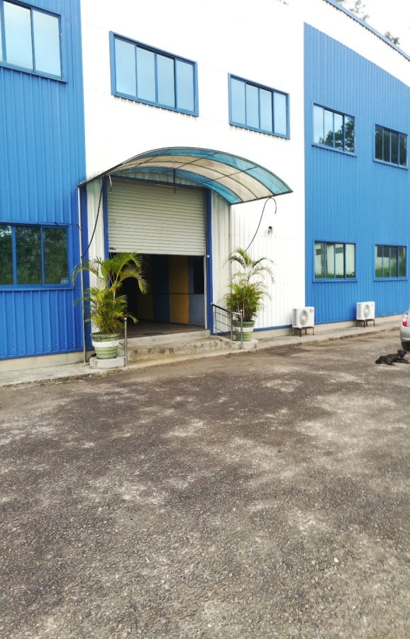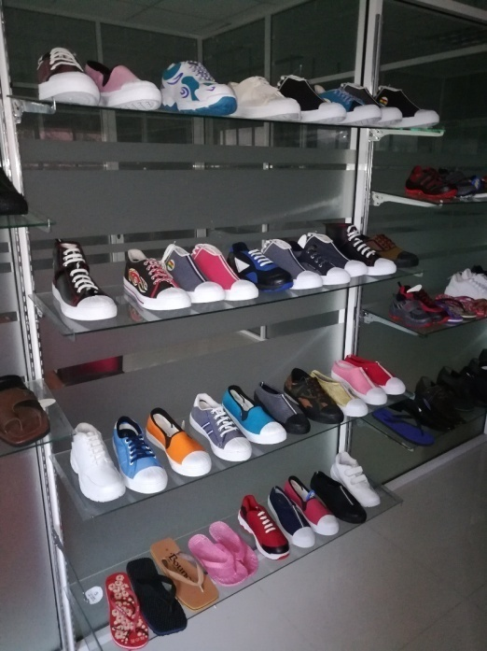

* School shoes
* Gents leather shoes
* Deck shoes
* Canvas shoes
* Nursing shoes
* Sport shoes
* Kids shoes
* Gents slippers
* Rubber slippers
* Beach slippers
* Health slippers
* Gents Chapels